Record No: 0614
AMANTHUS SHIPP
Wife of William Bellingham Somerville (0613).
Amanthus was 43 when she married William, who was 14 years her junior. She already had 3 sons, 2 surviving, so he probably would have known that there would not likely be any more children born to her. He had recently been demitted from the Union army where he was a Colonel, and she was a wealthy heiress, so a good match for them both.
Birth: 8 December 1825 Louisville, Kentucky to Ewell Shipp(0615) by his wife
Evelyn, nee Bray, plantation owners from Virginia.
The Shipp family came from England in mid to late 1600’s and settled in Essex Co., Virginia, then Caroline and Culpepper Counties. Known descents are: Josiah to Richard to Thomas to Edmund to Ewell to Amanthus Shipp Buckner Somerville. Thomas was born in Essex Co., Virginia, served in the Revolutionary War, and died in 1776 in Caroline Co., Virginia. He had three sons: Richard, born 1747, Edmund, born 1753 in either Caroline or Culpepper Co., Virginia, and Lemuel. Richard and Lemuel married sisters Elizabeth and Lucy Doniphen. In 1784 Richard and Elizabeth, and their family, and probably other Shipps, moved in a group called “The Travelling Church” to Kentucky, where they settled on vast land grants. Edmund, the second son, married Tabitha Garnett, and they had Ewell Shipp in 1785. Ewell married Evalina Bray in Nov 1, 1821, and amongst others, they gave birth to Amanthus Shipp on December 8, 1825.
Further detail re Shipp family is found under Ewell Shipp Profile
Ewell Shipp’s farm was located where the University of Illinois is now. Shipp St. would be almost in the middle of the campus (From A Centennial History of the University of Louisville on google books, p. 65.
Lying within one of the early tracts identified in the Fincastle surveys of 1774, which rewarded Virginia veterans of the French and Indian Wars, the land that became this new Third Street eventually was
owned by Ewell Shipp. His heirs sold the land to Thomas Browne, who in turn sold 82.5 acres to the city of Louisville for about $10,000 in 1850. It was specified by Browne that the land be used for the benefit
of the public. This property was occasionally referred to as the "Southern Cemetery" and was known legally as the Oakland Cemetery, although there is no evidence that anyone was ever buried there. Shipp Street, for many years the northern border of the campus, was named for Ewell Shipp (p. 68).

Marriage: (1)23 June 1846 Leander Buckner; he died 22 November 1855; buried
Cave Hill Cemetery, Louisville, Kentucky.
(2)1 August 1868 William Bellingham Somerville (0613): he died
24 April 1897; buried 28 April 1897 Woodland Cemetery, Cleveland.
Death: 26 October 1906 Kirkwood, Missouri; buried 27 October 1906 Cave
Hill Cemetery, Louisville, Kentucky.

Notes: Amanthus Buckner had three children by Leander Buckner
1 Ewell S Buckner, born 1847
2 William Henry Buckner, born 1848, died 30 December 1852
Buried Cave Hill Cemetery, Louisville Kentucky.
3 Edmund Garnett Buckner, born 8 September 1850
Census of 1850: Roll M432_207, page 251, Jefferson Co., Louisville Dist 3. Dwelling 216, family 216.
Goddard, Wm H. 40 m dentist born MA
" Wm H Jr. 20 m dentist NY
" Mary E 7 f KY
" Edward A 5 m KY
Brown, Thomas E., Jr 26 m dep sheriff Ireland
" Adelia M 21 f KY real estate value $18000
Shipp Samuel B 28 m dep sherrif KY real estate value $8000
Buckner Leander 32 m clerk KY
" Amanthis 26 f KY real estate value $8000
" Ewel S 3 f KY
" Wm H (?) 2 m KY
Shipp Edward G 19 m farmer KY real estate value $8000

Census of 1860: Roll M653_377; page 116 (or 1060?) dated Aug 14 1860: Dwelling 865, Family 824, Jeferson Co, Kentucky, St. Matthews P.O. Dist 2:
Browne, Thomas 37 male banker born Ireland
Browne, Adelia 29 female Kentucky
Browne, Eveline 7 female Kentucky
Buckner, Amanthus 32 female Kentucky
Buckner, Ewell S 13 male Kentucky attending school
Buckner, Edmond G 8 male Kentucky attending school

In the Census of 1900, Amanthus is shown living with her son Ewell, his wife Eliza, their
son Leander and Eliza’s mother Emily. The census shows Amanthus Somerville gave birth to 3 children,
2 of whom are living. William Henry is the child that died in 1852, and Ewell and Henry are the 2
surviving sons. It follows that there were no children of the marriage with William Bellingham
Somerville.
Corry said in a letter that his (male)line would die with his son William Bellingham.
Amanthus is buried in Kentucky beside Leander and William Henry is buried on the other side of
Leander.
At one time the Heirs of Amanthus Shipp owned shares in an oil company at Catron Creek, Kentucky, which was still paying dividends, until at least 1941.

Source: Somerville Index and Wendy Stevenson.
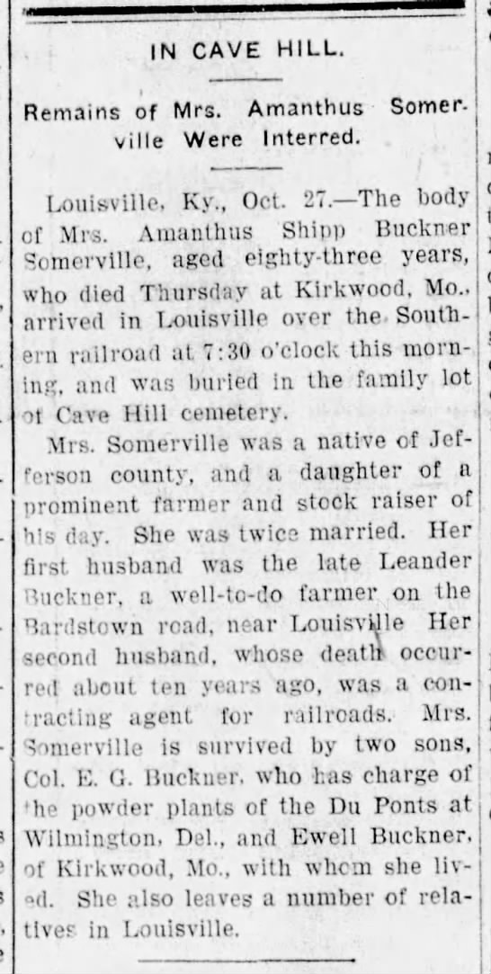

Source: Somerville Index and Wendy Stevenson.

